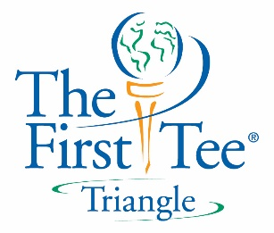
Activity Equipment Needs for
Drive4Success After-School Program

- Two bags of Snag Equipment (clubs, balls, launch pads, targets- rolleramas, flagstickys, bullseyes)
- Poly-spots
- Cones- dome and medium/large standard
- Hula Hoops (~30)
- Pool Noodles (~10)
- Bean Bags (~20)
- Surveyor’s tape* (or yarn)
- Tees*
- Alignment Sticks*
- Buckets/Pails/Crates
- Gymnastics Mats (2)
- Masking Tape &/or Painter’s Tape
- Pencils
- Scorecards
- Playing Cards (numbered index cards)
- Assorted balls: gator, tennis, golf, nerf football, playground ball, etc.
- Assortment of regular golf clubs, birdie balls, and birdie ball launch pads for lesson 6
- Bowling pins or empty water bottles
- Chalk powder in squeeze bottles*
- NEW Yardage Books
- Birdie balls, launch pads, and tunnel targets
- Bag of assorted, regular clubs
- Optional: Sidewalk chalk, water balloons, clipboards, scarves/bandanas, spray paint

*These will be provided by TFTT.
New for Second Session Lessons

